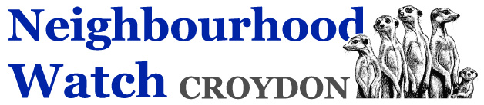

Minutes of the CBNWA AGM 6th November 2021

- Report from 2020 AGM
  - The chairman reported that comments received had been dealt with by January 21st and as such the Chairmans report & Accounts, which could be viewed on the web site. were agreed by default.
- Matters Arising
  - There were no matters arising.

- Chairmans Report
  - The Chairman report verbally that it had been “another difficult year” Having been elected in 2010 he wondered how many times he had made that comment, however he emphasised that funding was particularly difficult given the circumstances with Croydon Council being unable to grant further funding for us. He also raised the issue of recruiting new members to the committee which was essential if the organisation was to fluish.
  - He thanked the school, especially Colin, the committee members, and the co-ordinators who had kept up the good work in these difficult times.
  - He also thanked Chris the treasurer for his hard work, as he had expressed his wish to retire from this post as soon as possible and asked for volunteers to take his place.
  - We continue to seek funding from other sources, and new recruits across the borough, and photo opportunities to promote the organisation, such as our resent “Local Hero Award” which received good publicity in the local press.

- Accounts
  - The accounts for the year ending 31st March 2021 were agreed.

- Independent Examiner
- The Hon. Independent Examiner had agreed to remain in office and was thanked accordingly.

- Nominations for Committee
- The nominations on the agenda were approved by the meeting.

- Constitution Amendments
- Paul Voden took questions from the floor about the proposed changes to the Constitution which had been circulated to members prior to the meeting.
- He explained that most of the changes were to keep pace with changing technologies, and the reorganisation of the police in the borough. The changes were agreed by the meeting.
- The constitution would be reviewed annually to make sure it still met the needs of the charity.

- AOB
No questions were raised under this item.

